**1. INTRODUCTION**

With the reach of several technologies such as GPS, Wi-Fi, Bluetooth and NFC, RFID technology has been the most prominent. Even though technologies like GPS produce accurate results in identifying the location, they are not so efficient to track the objects that are inside a building. This is where RFID comes into use. RFID technology identifies the location in closed range proximity.

A well-organized architecture is designed to define the implementation of the RFID technology. The necessary equipment is gathered to implement the process. The type of RFID tag is chose according to the need. This implementation uses passive RFID tags. Passive RFID tags use Radio Frequency power that is emitted from the readers to power the tag.

The architecture defined uses a closed environment that is filled with RFID tags and the device or the object to be a reader. When the device enters the environment, it captures the tags and emits a signal corresponding to the location in which it is. The signal is received by the server that maintains the data about the location and presents it on a GUI that emulates the actual location.

With all the research knowledge that is available, any RFID technology that has been implemented so far have, security and reliability issues. With time, security has been developed but reliability is still an undergoing development in the field of RFID technology. This paper discusses few reliability concerned situations where most of the reliability is affected.

**2. ARCHITECTURE OF THE SYSTEM**

The architecture of the system is defined in two sections, the hardware and the software. The hardware of the system consists of a main station, database server, RFID readers and RFID tags (See Figure 1).

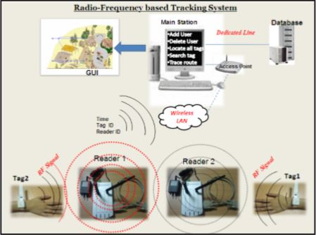

Figure 1: Hardware Architecture [1].

The main station or the monitoring station is connected to a wireless access point through Wireless LAN. A database server is also connected to the access point. On the other hand of the wireless access point, connected are RFID readers and RFID tags. The RFID tags may be embedded to wrist watches (Smart watch), mobile phones or tablets.

Typical software architecture consists of a Communication module, Application Programming Interface (API) module, User Visualization Software and a Database. A communication module checks the connection between the master station and receiver end. An API handles the data and tracks all the readings from the readers. User Visualization Software displays the real-time tracking of the entities on a GUI through communication module. All the readings and the data are stored in a database on a server.

**3. TRACKING SYSTEM**

The tracking system is capable of tracking mobile devices using passive RFID tags within a closed environment. The indoor environment is equipped with sensing surfaces usually floors, walls and sometimes tables. Entities are identified using these sensing surfaces. These sensing surfaces are divided into equal size grids that have small squares called location units. Each location unit is assigned an Identification Code (ID)**.** Using this identification code the system identifies the entities in the spaceand maps them to a small physical space. The only way to locate an entity in space is by knowing the ID associated with it. Initially to obtain the ID of a particular location unit a unique ID must be physically assigned to the surface to retrieve the location. Passive RFID tags are used in this implementation. Each tag represents a single location unit. Similarly a grid of tags represents a complete sensing surface. The object that retrieves the data from the passive RFID tags is embedded into the device or the entity. The reader reads the tags that are on the grid and retrieves the ID from each nearby unit. The ID is then sent to the location manager over a wireless communication module. The location manager maps the ID to the physical surface. The location manager is connected with the location unit and the physical sensing surface (See Figure 2).

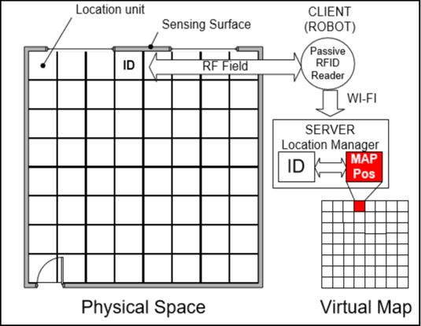

Figure 2: Tracking Module concept [4].

Software for the system is designed based on the client-server architecture. The client represents the devices/entities that need to be located in the confined space. The server is the representation of the location manager. Clients are comprised of two components: the RFID tag reader and the wireless communication module over which the ID is transmitted. The devices/entities are light weighted because all they perform is reading process from the RFID tags. The tags themselves are small too, because they do not have the power supply. The tags depend on the signals emerging from the readers. The server on the other hand contains all the physical locations mapped by the location manager and other miscellaneous information. The process is being performed in an indoor environment where a Wi-Fi enabled network is used for communication with the server and the client. TCP-IP protocols are used for such communications.

The server has three components: a wireless connection system with an access point, a physical to virtual location mapping system [4], a screen that displays the device/entity location. ID’s are received by the wireless connection system from the client. Then the physical surface location is mapped to a virtual location system where every entity is view in a real-time scenario. Later the display is passed on to a screen. The architecture is shown below in Figure 3.

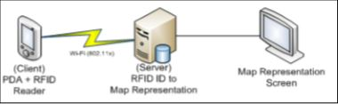

Figure 3: System architecture [3].

The issue that concerns now is the way to represent these ID’s to an actual indoor environment. The actual process begins with the retrieval of the location unit using the ID that was obtained from the entity from the database. This location unit is part of the sensing surface assuming that it is usually the floor or a wall. Using the ID we can locate the room, eventually the floor and the building in which the entity is. The result is a complete path to the entity that has to be identified.

**4. RELIABILITY**

Even with the tremendous functionality that RFID provides, the technology still faces some security and reliability challenges. These issues can limit the technology use to little applications. Reliability is defined as, the probability of a RFID reader to detect the RFID tags. Reliability of a RFID tag depends on several factors such as, orientation of the tag, inter-tag distance [2], distance between the tag and antenna [2], location of the tag.

**Read Range:** The read range of a RFID tag is the distance that the reader can read the RFID tag. This range depends on the frequencies that the tags are working on. For example, an Ultra High Frequency (UHF) system the range is few meters.

**Inter-Tag Distance and Orientation:** The location of the tag is different in different scenarios. The distance between tags and the orientation along which the tags are aligned to the antenna can change the performance. This has a huge impact on reliability.

**Object Tracking:** In real-time scenario, tags are attached to devices and they may interfere with Radio Frequency signals. Reliability depends on the location of the tag that it is on. The tag locations can vary and improve the mean of reliabilities. The furthest tag has less reliability and the closest tag to the antenna has more reliability.

**5. CONCLUSION**

Using RFID technology to track a user inside a building is an efficient way to improve location tracking system. With this technology it is easy to implement several different schemes to track the user. Each scheme has different levels of abstraction to identify the user and produce different levels of reliability. This is a simple and cost efficient implementation to track the location. There are many researches being conducted to develop the uses of RFID technology to make it the most efficient and reliable way to track objects in both indoor and outdoor environment.

**References**

[1] A. R. Al-Ali, Fadi A. Aloul, Nada R. Aji, Amin A. Al-Zarouni, Nassar H. Fakhro, Mobile RFID Tracking System. *Information and Communication Technologies: From Theory to Applications.* ICTTA 2008 (7-11 April 2008, Damascus), 1-4.

[2] Ahmed Rahmati, Lin Zhong, Matti Hiltunen, Rittwik Jana, Reliability Techniques for RFID-Based Object Tracking Applications. *Dependable Systems and Networks, 2007, DSN ’07. 37th Annual IEEE/IFIP International Conference* (25-28 June 2007, Edinburgh), 113-118.

[3] Kirti Chawla, Gabriel Robins, Liuyi Zhang, Efficient RFID-Based Mobile Object Localization. *Wireless and Mobile Computing, Networking and Communications (WiMob), 2010 IEEE 6th International Conference* (11-13 Oct. 2010, Niagara Falls, ON), 683-690.

[4] Ricardo Tesoriero, Jose A. Gallud, Maria D. Lozano, Victor M. R. Penichet, Tracking Autonomous Entities using RFID Technology. *Consumer Electronics, IEEE Transactions,* Volume: 55, Issue: 2, (May 2009), 650-655.